BRACT’s
Vishwakarma Institute of Technology, Pune
Practical Implementation Sheet
Department: CSE-AI Semester: 5 Academic Year: 2026-27
Division: E Batch: 1 Practical No: 1
Roll no: 08 PRN No: 12412097 Name of Student: Sahil Balasaheb Patil
Subject Name : Deep Learning

Problem Statement :
Install and configure TensorFlow/Keras in Google Colab. Perform data preprocessing, normalization, train-test split, and visualization on a sample dataset.
Algorithm :
Step 1: Import Libraries
- Import TensorFlow for building the neural network.
- Import Matplotlib for visualizing images.
Step 2: Load Dataset
- Load the MNIST handwritten digit dataset.
- Split the dataset into:
  - Training set
  - Testing set
Step 3: Preprocess the Data
- Normalize pixel values from 0–255 to 0–1 by dividing every pixel by 255.
- This helps the neural network train faster and improves convergence.
Step 4: Visualize the Dataset
- Display sample images.
- Verify the image size (28 × 28 pixels).
- Check corresponding labels (digits 0–9).
Step 5: Build the Neural Network
Create a Sequential Neural Network consisting of:
- Flatten Layer
  - Converts each 28 × 28 image into a 784-element vector.
- Hidden Layer
  - Dense layer with 128 neurons.
  - Activation function: ReLU.
- Output Layer
  - Dense layer with 10 neurons (one for each digit).
  - Activation function: Softmax to produce class probabilities.
Step 6: Compile the Model
Configure the model using:
- Optimizer: Adam
- Loss Function: Sparse Categorical Crossentropy
- Evaluation Metric: Accuracy
Step 7: Train the Model
- Train the neural network using the training dataset.
- Run training for 3 epochs.
- During training:
  - Perform forward propagation.
  - Calculate loss.
  - Backpropagate errors.
  - Update weights using the Adam optimizer.
Step 8: Evaluate the Model
- Test the trained model on unseen test data.
- Calculate:
  - Test Loss
  - Test Accuracy
Step 9: Save the Model
- Save the trained model for future predictions without retraining.

Code :
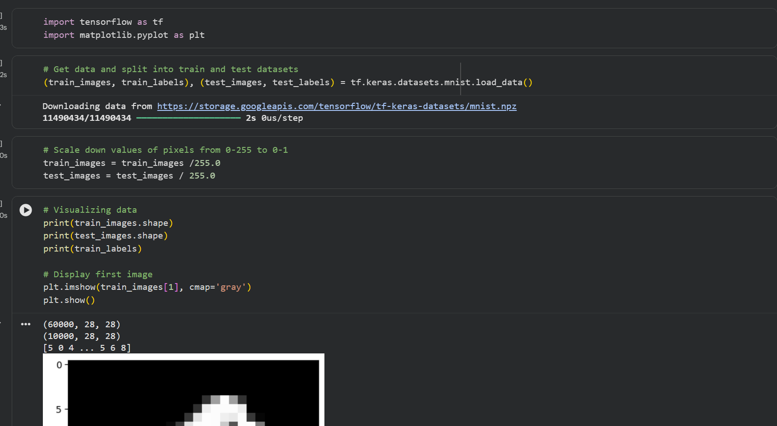
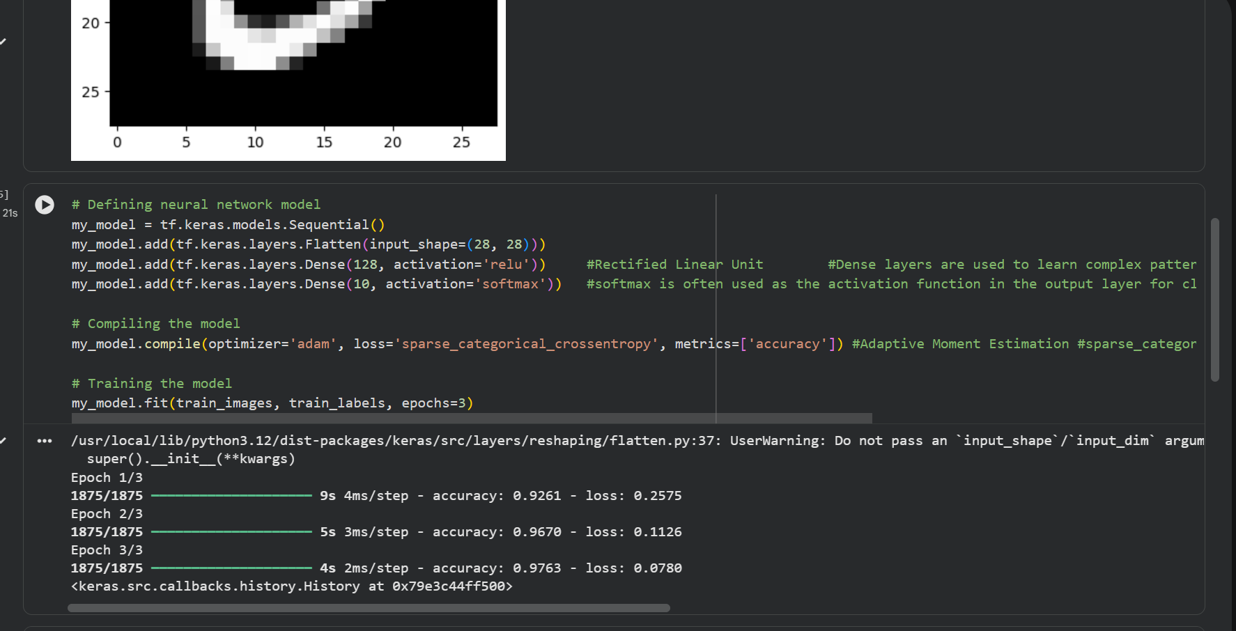

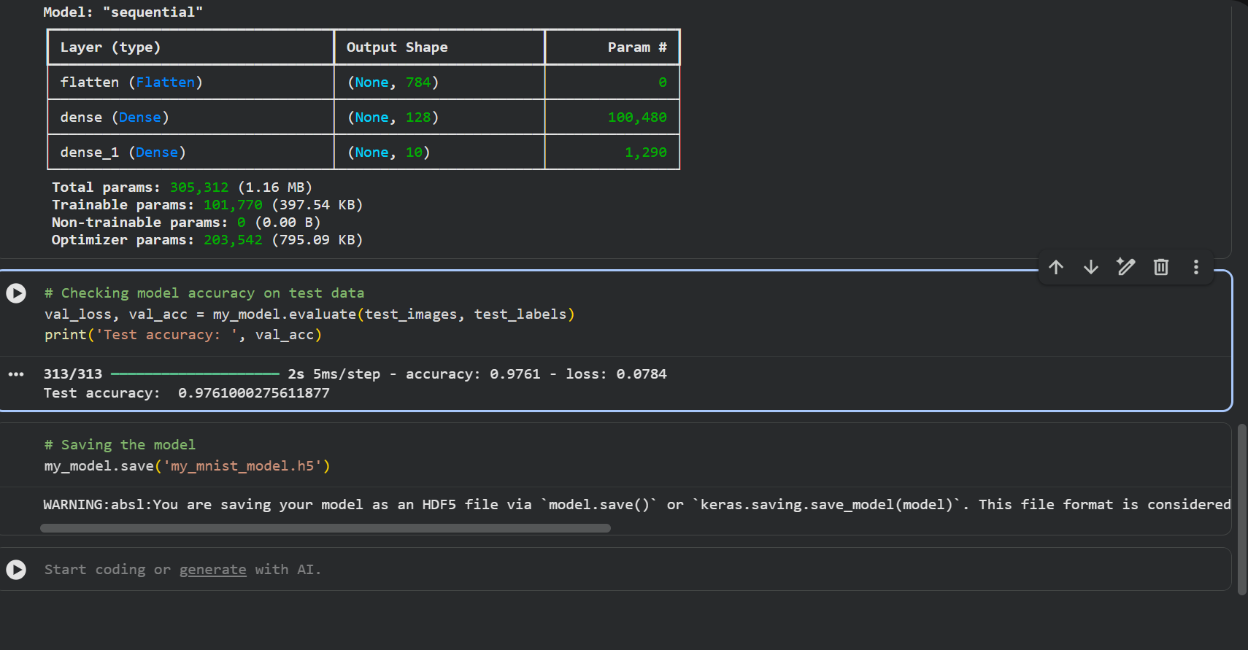

Output :
